**WEATHER.IO -WEATHER-APP**

**INTRODUCTION**

* 1. **OVERVIEW**

**Weather forecasting** is the application of science and technology [to predict](https://en.wikipedia.org/wiki/Forecasting) the conditions of the [atmosphere](https://en.wikipedia.org/wiki/Earth%27s_atmosphere) for a given location and time. People have attempted to predict the weather informally for [millennia](https://en.wikipedia.org/wiki/Millennia) and formally since the 19th century.

Weather forecasts are made by collecting quantitative data about the current state of the atmosphere, land, and ocean and using [meteorology](https://en.wikipedia.org/wiki/Meteorology) to project how the atmosphere will change at a given place.

Once calculated manually based mainly upon changes in [barometric pressure](https://en.wikipedia.org/wiki/Atmospheric_pressure), current weather conditions, and sky conditions or cloud cover, weather forecasting now relies on [computer-based models](https://en.wikipedia.org/wiki/Numerical_weather_prediction) that take many atmospheric factors into account.[[1]](https://en.wikipedia.org/wiki/Weather_forecasting#cite_note-1) Human input is still required to pick the best possible model to base the forecast upon, which involves pattern recognition skills, [teleconnections](https://en.wikipedia.org/wiki/Teleconnection), knowledge of model performance, and knowledge of model biases.

The inaccuracy of forecasting is due to the [chaotic](https://en.wikipedia.org/wiki/Chaos_theory) nature of the atmosphere, the massive computational power required to solve the equations that describe the atmosphere, the land, and the ocean, the error involved in measuring the initial conditions, and an incomplete understanding of atmospheric and related processes. Hence, forecasts become less accurate as the difference between current time and the time for which the forecast is being made (the *range* of the forecast) increases. The use of ensembles and model consensus helps narrow the error and provide confidence in the forecast.

* 1. **PURPOSE**

A weather app is a way to use your mobile phone to check current, past, or future weather patterns and weather maps.

The weather app enables you make better preparation for the day in relation to giving accurate daily weather forecast. The app provides you with details of the weather elements – pressure, winds, precipitation. Browse interactive maps, satellite, radar, heat, snow, all when you download and install the weather app in your smartphone.

**Smart Notifications Based on The Current Weather Forecast**

The Weather Forecast app for Android and iOS can’t be completed without considering this must-have feature, which is called smart notifications or push notifications based on the current weather forecast. As such feature keeps reminding your app users to take an umbrella if there is about to rain outside or prepare themselves for heat strokes or high UV rays.

### **Hyper-Local Forecast**

The next important feature that you can’t miss before creating weather app is hyper-local forecast which predicts rain, storm, and weather changes with a per minute accuracy based on the user’s current location. To develop this feature, our developers make use of Dark Sky API to gain access to the same data.

### **Weather Visualizations With Stunning Maps**

Along with the prediction of current weather conditions, it is also important to offer your weather forecasting app users with stunning maps which allows them to explore weather conditions in the past and the future.

**LITERATURE SURVEY**

**2.1 EXISTING PROBLEM**

Another primary thing that the Weather application requires is access to the location. If the location is turned off on your device, the weather application cannot access precise weather information. Hence the problem of the weather app not working.

The weather application may not be working on your device because of a poor internet connection. Because of that, the weather application won’t be able to gather the necessary information. Likely, other causes include:

* The device location is turned off.
* Outdated Weather Application
* Outdated System Software
* The Weather App server may be down or under maintenance.

**2.2 PROPOSED SOLUTION**

Every weather app has different methods of gathering information. Some apps depend upon government satellite while some use their own technology and team of meteorologist. Most commonly used tools are weather satellite and Doppler radar.

Our weather app can produce the temperature and other weather conditions of any city without any location accessing. Our app can work on any type of system whether it is updated or outdated.

**THIORITICAL ANALYSIS**

**3.1 BLOCK DIAGRAMS**

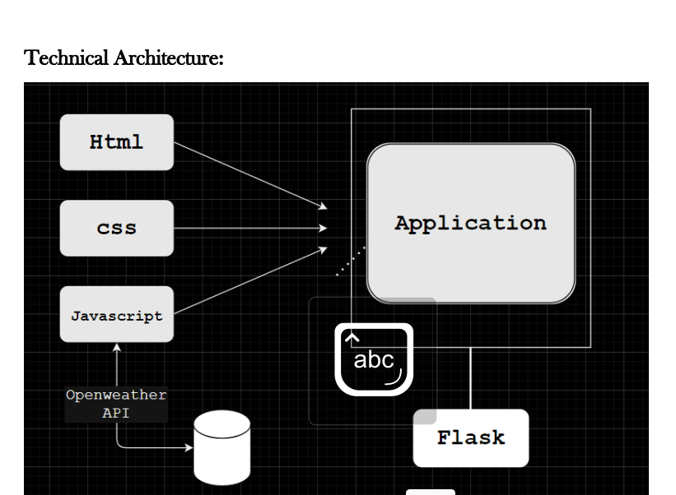

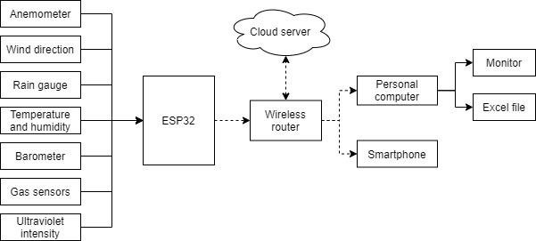

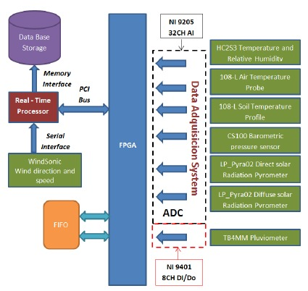

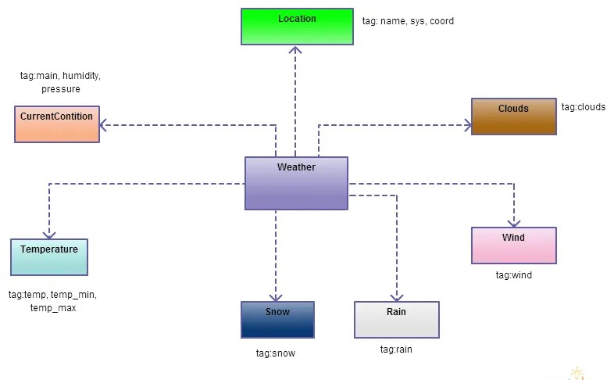

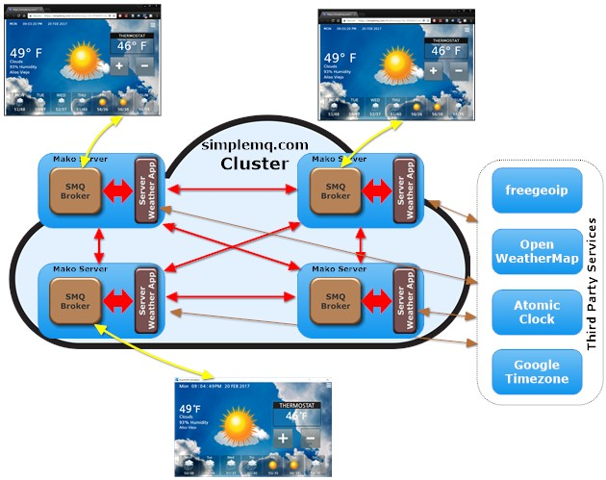

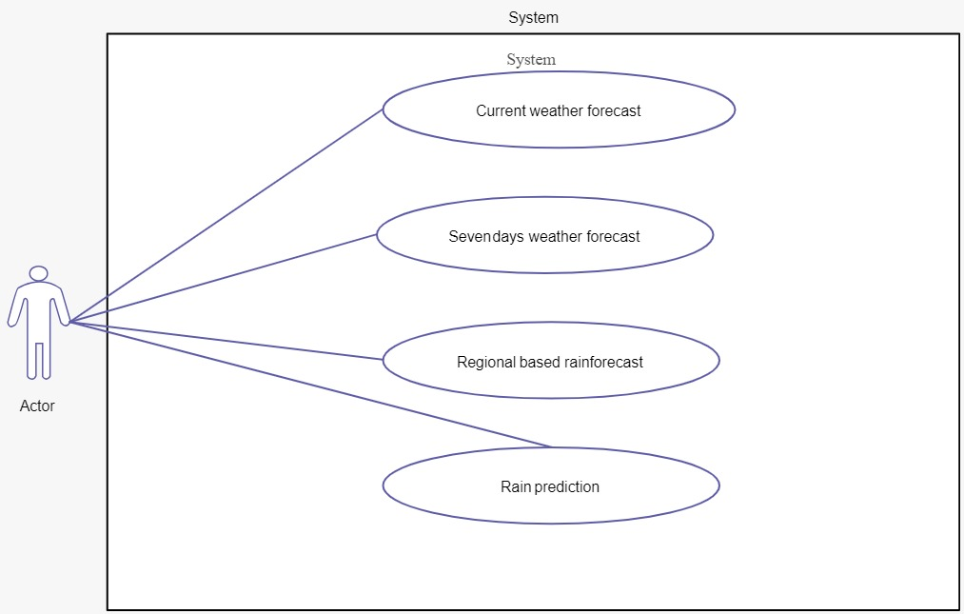

* 1. **HARDWARE AND SOFTWARTRE DESIGNING**
* Android mobile with a minimum version 2.2.
* The processor is not less than 500MHZ.
* RAM > 170mb.
* SD card with a minimum of 512 MB.
* Resolution is not less than 480*800pixs.

**Recommended System Requirements**

Often manufacturers of games will provide the consumer with a set of requirements that are different from those that are needed to run a software. These requirements are usually called the recommended requirements. These requirements are almost always of a significantly higher level than the minimum requirements, and represent the ideal situation in which to run the software. Generally speaking, this is a better guideline than minimum system requirements in order to have a fully usable and enjoyable experience with that software.

**Hardware Requirements**

The most common set of requirements defined by any [operating system](https://en.wikipedia.org/wiki/Operating_system) or [software application](https://en.wikipedia.org/wiki/Software_application) is the physical computer resources, also known as [hardware](https://en.wikipedia.org/wiki/Computer_hardware), A hardware requirements list is often accompanied by a [hardware compatibility list](https://en.wikipedia.org/wiki/Hardware_compatibility_list) (HCL), especially in case of operating systems. An HCL lists tested, compatible, and sometimes incompatible hardware devices for a particular operating system or application. The following sub-sections discuss the various aspects of hardware requirements.

### **Architecture**

All computer [operating systems](https://en.wikipedia.org/wiki/Operating_system) are designed for a particular [computer architecture](https://en.wikipedia.org/wiki/Computer_architecture). Most software applications are limited to particular operating systems running on particular architectures. Although architecture-independent operating systems and applications exist, most need to be recompiled to run on a new architecture. See also a list of [common operating systems](https://en.wikipedia.org/wiki/Comparison_of_operating_systems#Technical_information) and their supporting architectures.

### **Processing power**

The power of the [central processing unit](https://en.wikipedia.org/wiki/Central_processing_unit) (CPU) is a fundamental system requirement for any software. Most software running on [x86 architecture](https://en.wikipedia.org/wiki/X86_architecture) define processing power as the [model](https://en.wikipedia.org/wiki/List_of_microprocessors) and the [clock speed](https://en.wikipedia.org/wiki/Clock_rate) of the CPU. Many other features of a CPU that influence its speed and power, like [bus speed](https://en.wikipedia.org/wiki/Front_side_bus), [cache](https://en.wikipedia.org/wiki/CPU_cache), and [MIPS](https://en.wikipedia.org/wiki/Instructions_per_second) are often ignored. This definition of power is often erroneous, as different makes and models of CPUs at similar clock speed often have [different throughput speeds](https://en.wikipedia.org/wiki/Megahertz_myth).

### **Memory**

All software, when run, resides in the [random access memory](https://en.wikipedia.org/wiki/Random_access_memory) (RAM) of a computer. Memory requirements are defined after considering demands of the application, operating system, supporting software and files, and other running processes. Optimal performance of other unrelated software running on a multi-tasking computer system is also considered when defining this requirement.

### **Secondary storage**

Data storage device requirements vary, depending on the size of software installation, temporary files created and maintained while installing or running the software, and possible use of [swap space](https://en.wikipedia.org/wiki/Virtual_memory) (if RAM is insufficient).

### **Display adapter**

Software requiring a better than average [computer graphics](https://en.wikipedia.org/wiki/Computer_graphics) display, like [graphics editors](https://en.wikipedia.org/wiki/Graphics_software) and high-end [games](https://en.wikipedia.org/wiki/Video_game), often define high-end [display adapters](https://en.wikipedia.org/wiki/Graphics_processing_unit) in the system requirements.

### **Peripherals**

Some software applications need to make extensive and/or special use of some [peripherals](https://en.wikipedia.org/wiki/Peripheral), demanding the higher performance or functionality of such peripherals. Such peripherals include [CD-ROM drives](https://en.wikipedia.org/wiki/CD-ROM), [keyboards](https://en.wikipedia.org/wiki/Computer_keyboard), [pointing devices](https://en.wikipedia.org/wiki/Pointing_device), [network devices](https://en.wikipedia.org/wiki/Computer_networking_device), etc.

**Software Requirements**

[Software requirements](https://en.wikipedia.org/wiki/Software_requirements) deal with defining software resource requirements and prerequisites that need to be installed on a computer to provide optimal functioning of an application. These requirements or prerequisites are generally not included in the software installation package and need to be installed separately before the software is installed.

### **Platform**

A [computing platform](https://en.wikipedia.org/wiki/Computing_platform) describes some sort of [framework](https://en.wikipedia.org/wiki/Software_framework), either in [hardware](https://en.wikipedia.org/wiki/Computer_hardware) or [software](https://en.wikipedia.org/wiki/Software), which allows software to run.[[2]](https://en.wikipedia.org/wiki/System_requirements#cite_note-2) Typical platforms include a computer's [architecture](https://en.wikipedia.org/wiki/Computer_architecture), [operating system](https://en.wikipedia.org/wiki/Operating_system), or [programming languages](https://en.wikipedia.org/wiki/Programming_language) and their [runtime](https://en.wikipedia.org/wiki/Run-time_system) libraries.

[Operating system](https://en.wikipedia.org/wiki/Operating_system) is one of the requirements mentioned when defining system requirements (software). Software may not be compatible with different versions of same line of operating systems, although some measure of backward compatibility is often maintained. For example, most software designed for [Microsoft Windows XP](https://en.wikipedia.org/wiki/Microsoft_Windows_XP) does not run on [Microsoft Windows 98](https://en.wikipedia.org/wiki/Microsoft_Windows_98), although the converse is not always true. Similarly, software designed using newer features of [Linux Kernel](https://en.wikipedia.org/wiki/Linux_Kernel) v2.6 generally does not run or compile properly (or at all) on Linux distributions using Kernel v2.2 or v2.4.

### **APIs and drivers**

Software making extensive use of special hardware devices, like high-end [display adapters](https://en.wikipedia.org/wiki/Graphics_processing_unit), needs special [API](https://en.wikipedia.org/wiki/Application_programming_interface) or newer device drivers. A good example is [DirectX](https://en.wikipedia.org/wiki/DirectX), which is a collection of APIs for handling tasks related to multimedia, especially game programming, on [Microsoft](https://en.wikipedia.org/wiki/Microsoft) platforms.

### **Web browser**

Most [web applications](https://en.wikipedia.org/wiki/Web_application) and software depend heavily on [web technologies](https://en.wikipedia.org/wiki/World_Wide_Web) to make use of the default browser installed on the system. [Microsoft Edge](https://en.wikipedia.org/wiki/Microsoft_Edge) is a frequent choice of software running on [Microsoft Windows](https://en.wikipedia.org/wiki/Microsoft_Windows), which makes use of [ActiveX](https://en.wikipedia.org/wiki/ActiveX) controls, despite their vulnerabilities.

**OTHER REQUIREMENTS**

Some software also has other requirements for performance. [Internet connection](https://en.wikipedia.org/wiki/Internet_connection) (type and speed) and [resolution](https://en.wikipedia.org/wiki/Display_resolution) of the display screen are notable examples.

**RESULT**

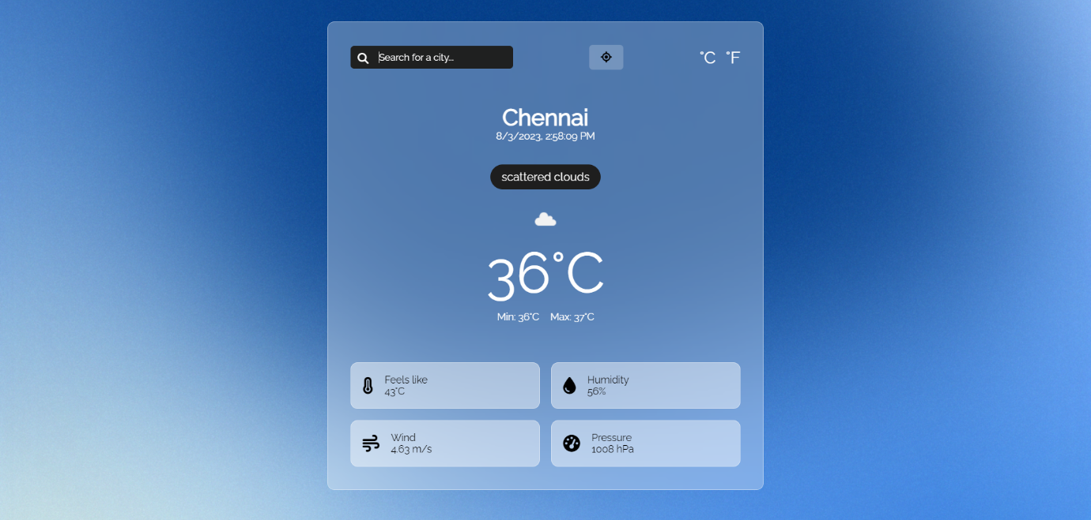

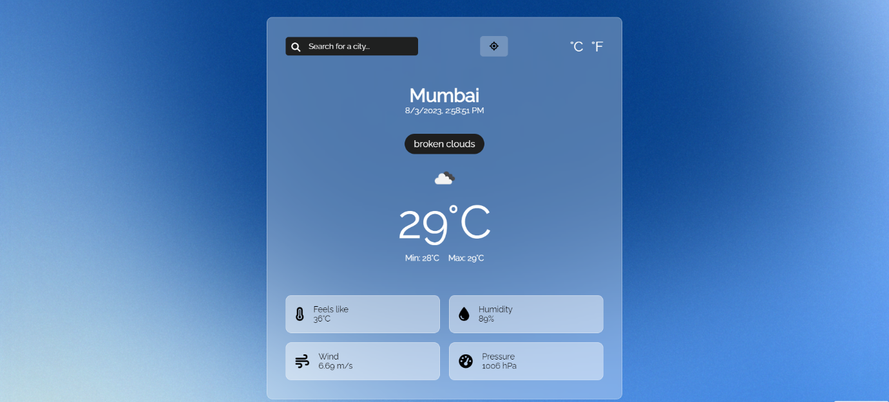

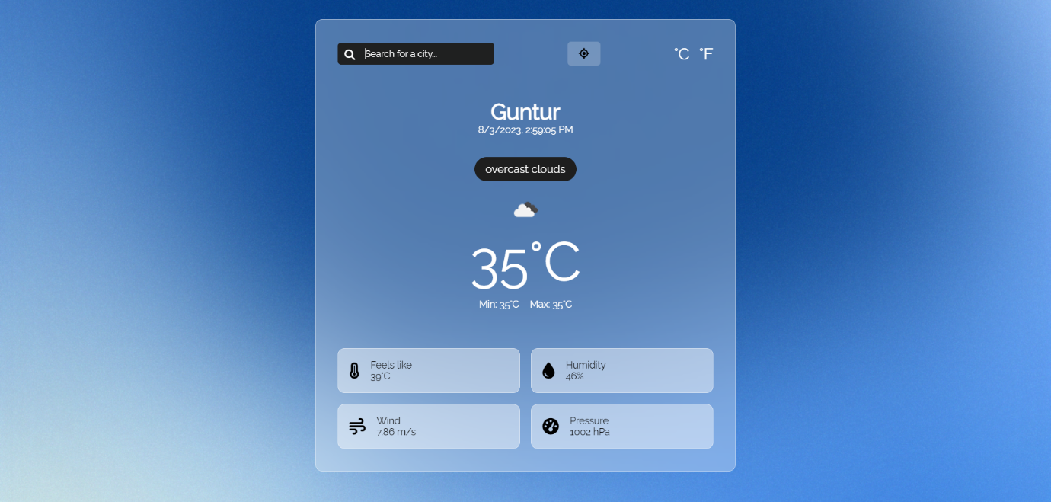

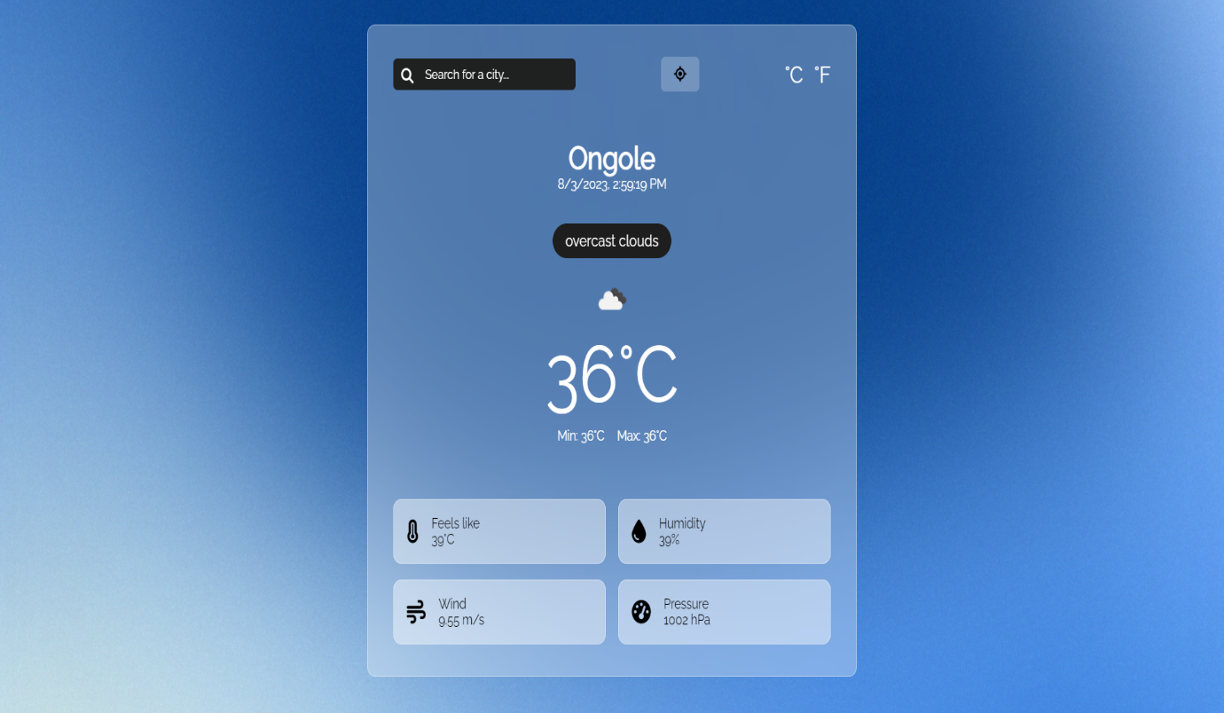

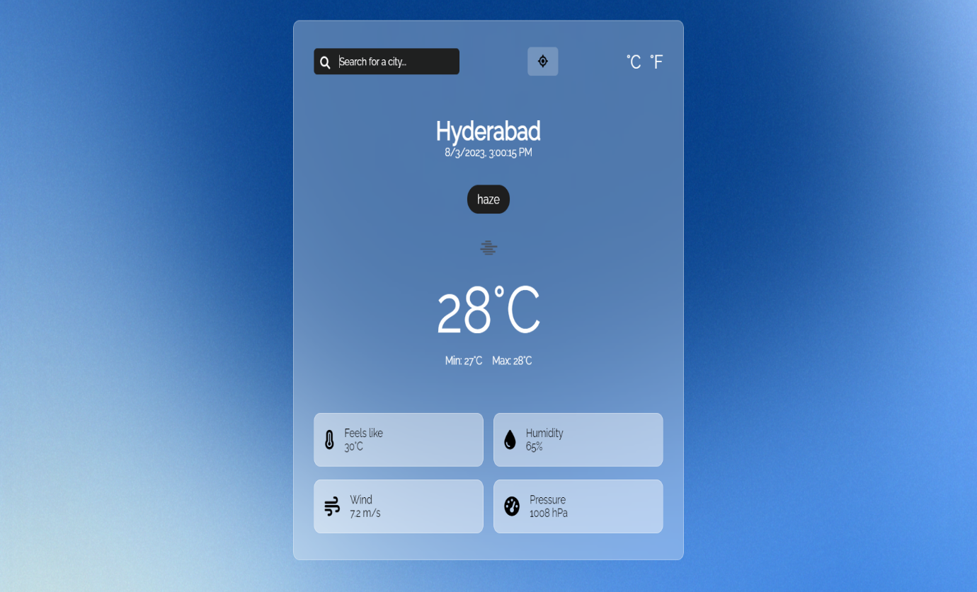

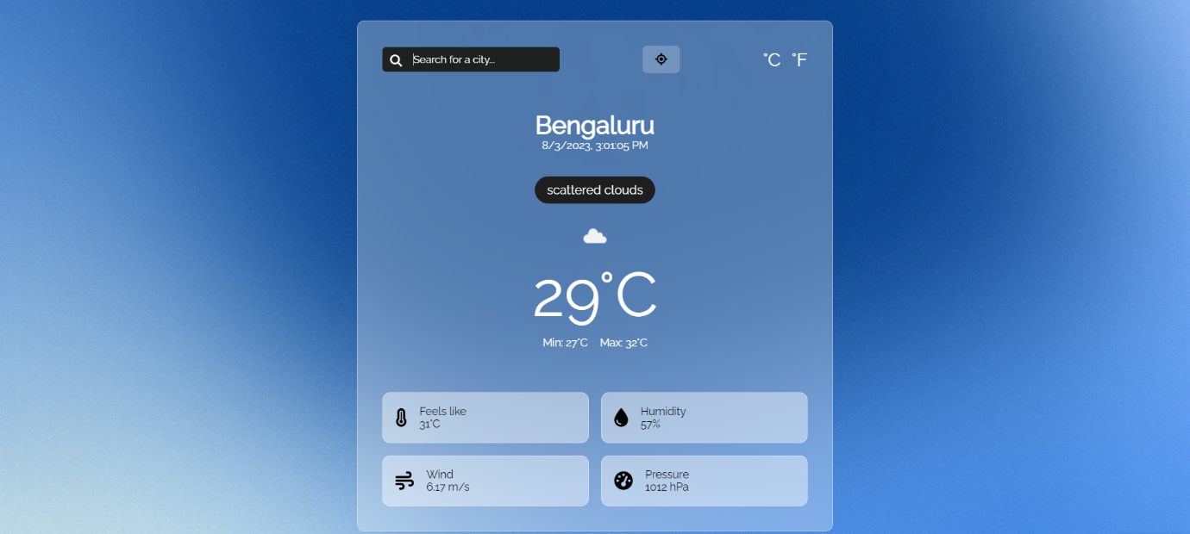

**ADVANTAGES AND DISADVANTAGES**

**ADVANTAGES:**

* Farmers can known when to plant or harvest their crops.
* People cam choose where and when to take their holidays to take advantages of good weather.
* Surfers known when large waves are expected.
* Regions can be evacuated if hurricanes or floods are expected.
* Instant information availability. Improved Weather forecast. Easy Flow of Information. Widget Support.
* Aircraft and shipping rely heavily on accurate weather forecasting.
* Real time data is one of the biggest **advantages of weather monitoring system.**
* The reasons why people have been going in for weather stations is because of the ability to get their information in real-time.
* Real-time alerts are other important **advantages of weather monitoring system.**
* These real-time alerts can be informed to you, and your family members about the weather, increasing survival, being safe for everyone.

**DISADVANTAGES:**

* Weather is extremely difficult to forecast correctly
* It is expensive to monitor-so many variables from so many sources
* The computers needed to perform the millions of calculations necessary are expensive
* The weather forecasters get blamed if the weather is different from the forecast
* Weather is extremely difficult to forecast correctly.
* It is expensive to monitor so many variables from many sources.
* the computers needed to perform the millions of calculations necessary are expensive
* The weather forecasters get blamed if the weather is different from the forecast
* Confusing Terminology: The terminology used in weather forecasting can be confusing, making it difficult for some people to understand the predictions.
* Reliance on Technology: Weather forecasting relies heavily on technology, and if the technology fails or is unavailable, accurate predictions cannot be made.
* Limited Reach: Weather forecasts are not available for many remote or sparsely populated areas, making it difficult for people in these areas to prepare for severe weather.

**APPLICATIONS**

* The most common application of weather apps is for personal use. People use these apps to check the weather forecast before planning their outdoor activities, trips, or daily routines.
* Weather apps help users decide what to wear, whether to carry an umbrella, or if it's safe to engage in outdoor sports.
* Travelers use weather apps to plan their trips more effectively.
* When organizing outdoor events like weddings, parties and contingency plans in case of adverse weather conditions.
* Farmers and agriculturalists use weather apps to monitor weather patterns, temperature fluctuations, and precipitation forecasts.
* Construction teams use weather apps to schedule tasks, ensure worker safety, and manage project timelines.
* Pilots and aviation professionals use weather apps to monitor weather conditions along flight paths and at airports.
* This information is crucial for flight planning, route adjustments, and ensuring passenger safety.
* These are just a few examples of the many applications of weather apps across different industries and daily life scenarios.
* As technology advances, weather apps continue to evolve, offering more accurate and detailed information to users.

**CONCLUSION**

The weather app provides a convenient and accessible way for users to obtain up-to-date weather information for their desired locations. By utilizing various data sources and possibly incorporating advanced forecasting models, the app can offer accurate and reliable weather forecasts, current conditions, and other relevant meteorological data.

In conclusion, the weather app is a valuable tool for users to plan their activities, make informed decisions, and stay prepared for changing weather conditions. Its user-friendly interface and comprehensive features contribute to its usability and effectiveness.

However, to maintain its relevance and usefulness, the app should continuously update its data sources, improve its algorithms, and consider incorporating user feedback to enhance its overall performance and user experience.

**FUTURE SCOPE**

The future scope of weather apps is exciting and full of potential, driven by advancements in technology, data availability, and user demands.

Weather apps have already come a long way, providing real-time weather forecasts, radar maps, and other valuable information. However, the future scope of weather apps continues to be promising and exciting, driven by advancements in technology and data analytics.

As technology and our understanding of weather patterns continue to evolve, the future of weather apps might hold even more surprises and innovative features.

The future scope of weather apps is vast and interconnected with various technological advancements. As more data becomes available and as user needs evolve, weather apps have the potential to become indispensable tools for individuals, communities, and even industries that rely on accurate weather information.